Pearl Barley and Charlie Parsley
This week we are going to change the question. We will ask, “Who Am I?” instead of What Am I? Let’s think about the characters, Pearl Barley and Charlie Parsley.
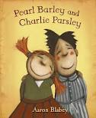
Who Am I?
I am a really good friend.
My friend is different to me.
I like to solve problems.
I like to talk all day long.
I am very loud.
My name is .
Now it’s your turn to write a riddle about Charlie Parsley. Think about all the things you know about Charlie Parsley.
WHO AM I?

