Name:
Paraphernalia
This week we are going to write two “Who am I?” riddles. This time it will be about the characters in the book, Paraphernalia’s Present.
Who Am I?
.
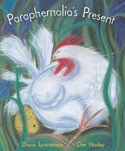
.
.
.
My name is Paraphernalia.

Who Am I?
.
.
.
.
My name is Dottie.

