Name:
Wanted: The Perfect Pet
This week we are going to write two “Who am I?” riddles.
The first one will be about one of the characters in the book, either the duck or Henry.
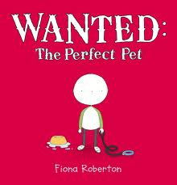
Who Am I?
.
.
.
.
My name is .
The second one is about a pet of your choice. Think of all the things that would make it a good pet. These ideas will become your clues.
Who Am I?
.
.
.
.
I am .

